Lab # 5 — Assessment Worksheet

**Course Name and Number: FRS301**

**Student Name: Tran Thanh Tuan**

**Student Id: SE161095**

**Instructor Name: Nguyen Van Vinh**

## **Mount Image File, Recover Deleted File**

***Log into WXP-SP2***

1. **Start VMware Player**

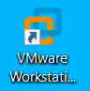

1. **Start Up WXP-SP2**

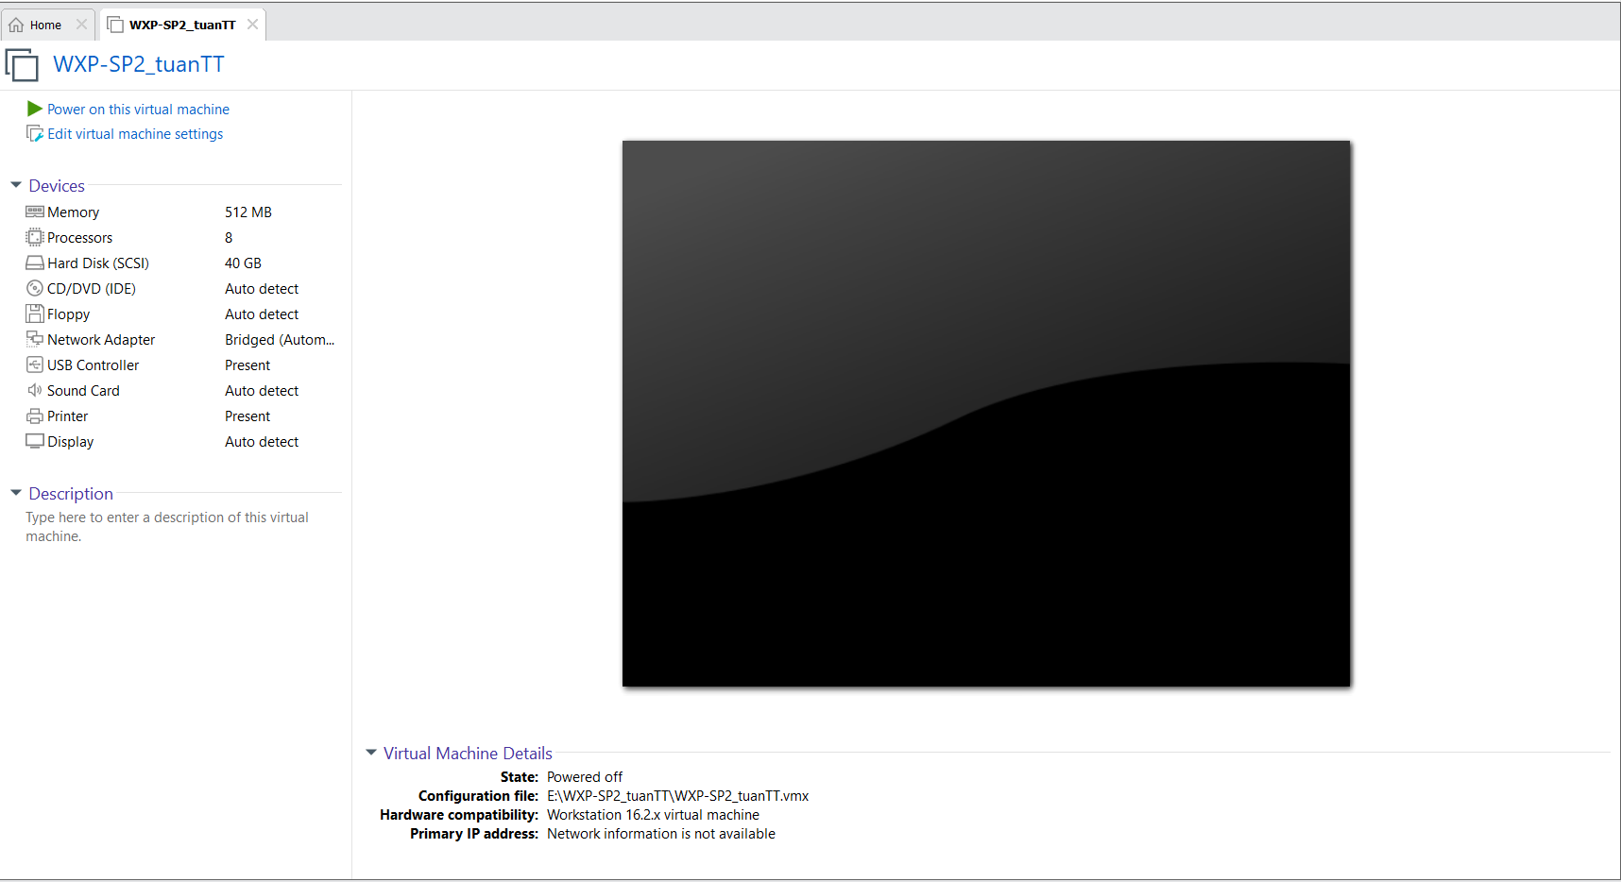

1. **Play Virtual Machine**



1. **Open a Command Prompt**



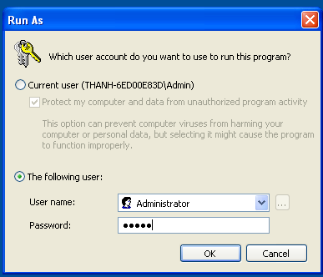

1. **Obtain WXP-SP2's IP Address**

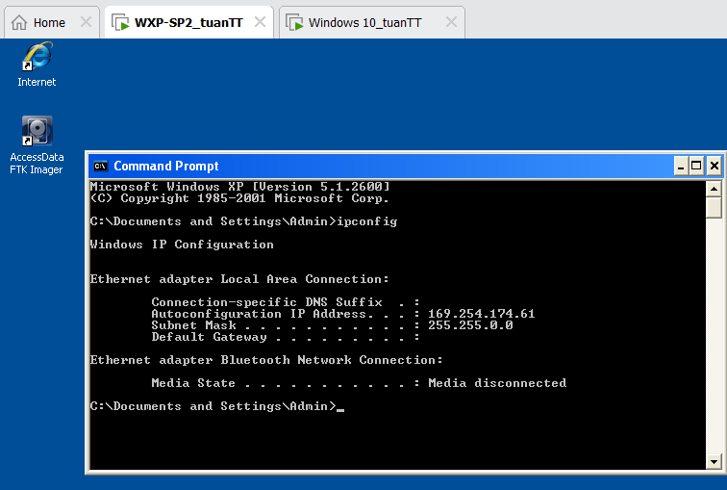

***Start FTK Imager***

1. **Start FTK Imager**

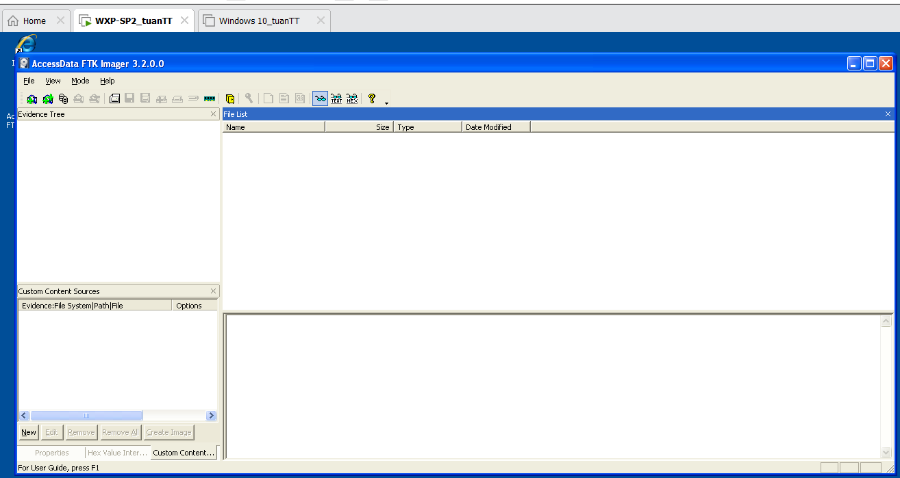

***Mount Image***

1. **Add Evidence**

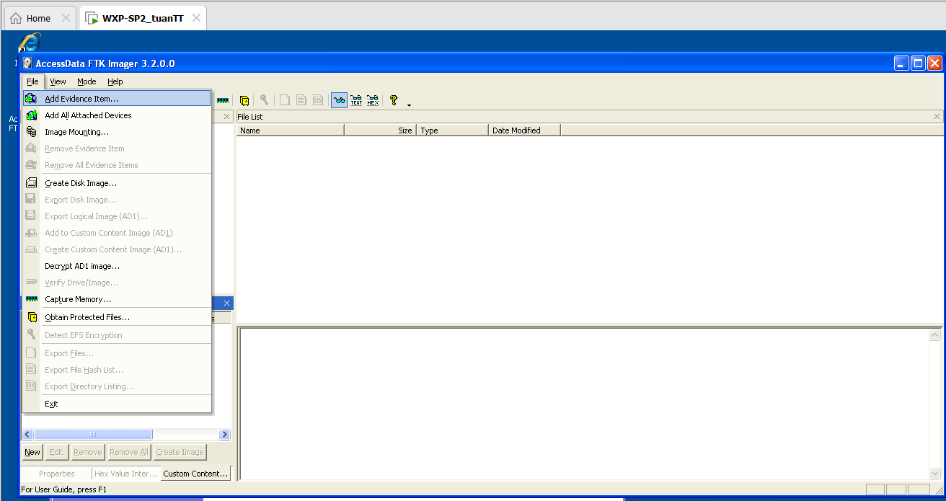

1. **Select Source**

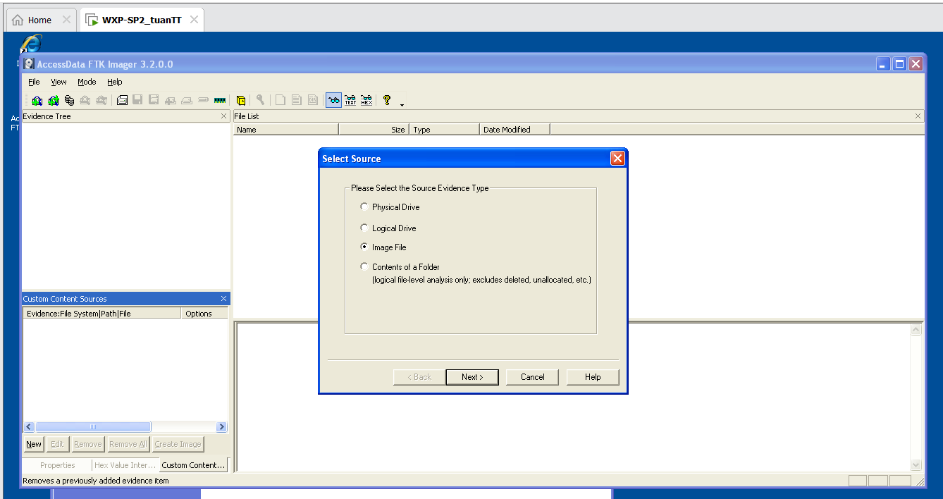

1. **Select File**

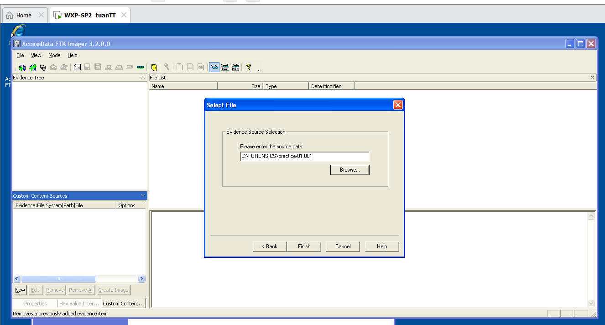

***View Deleted Image***

1. **View Deleted File(s) in the Recycler**

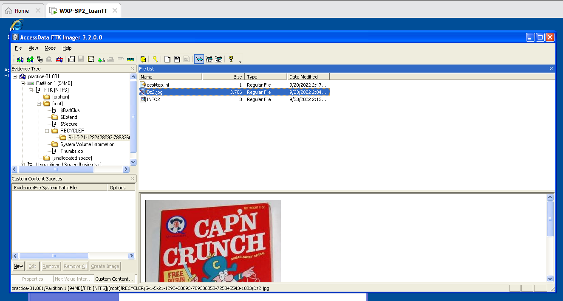

1. **View Deleted File(s) in [unallocated space]**

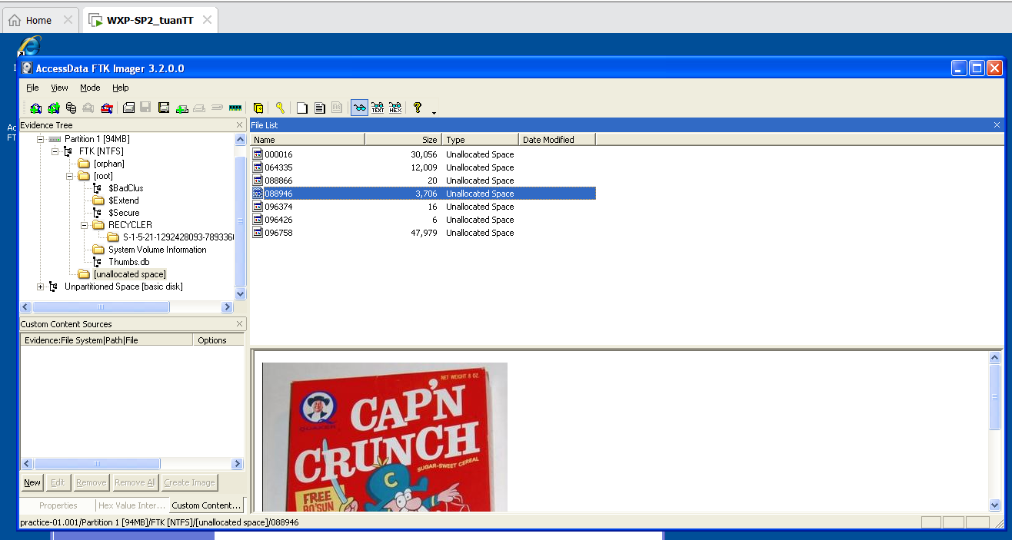

***Recover Deleted Image***

1. **Export File**

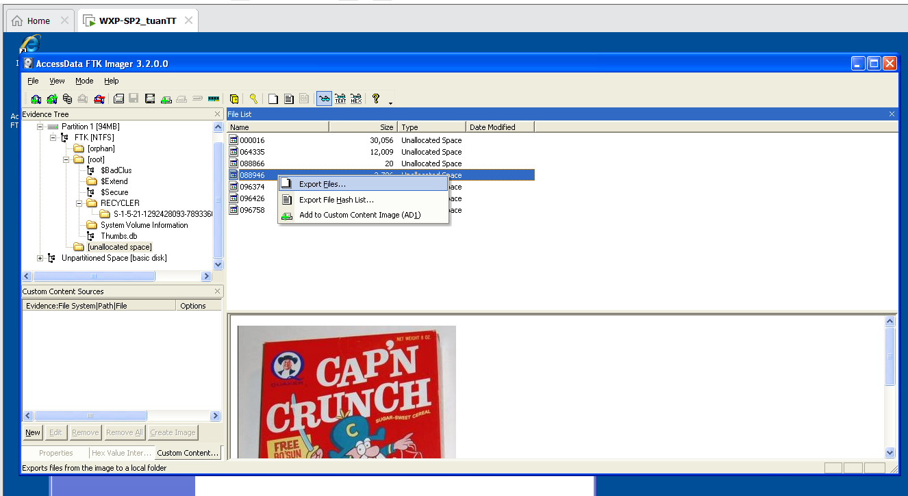

1. **Select the destination folder**

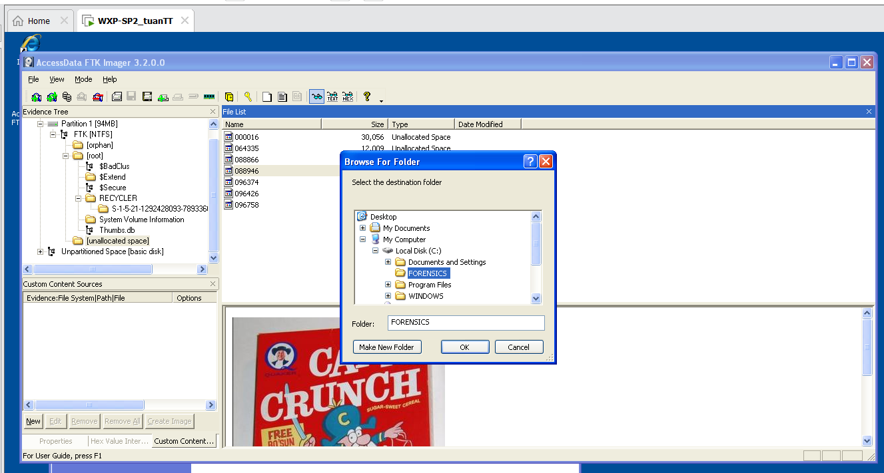

1. **Export Results**

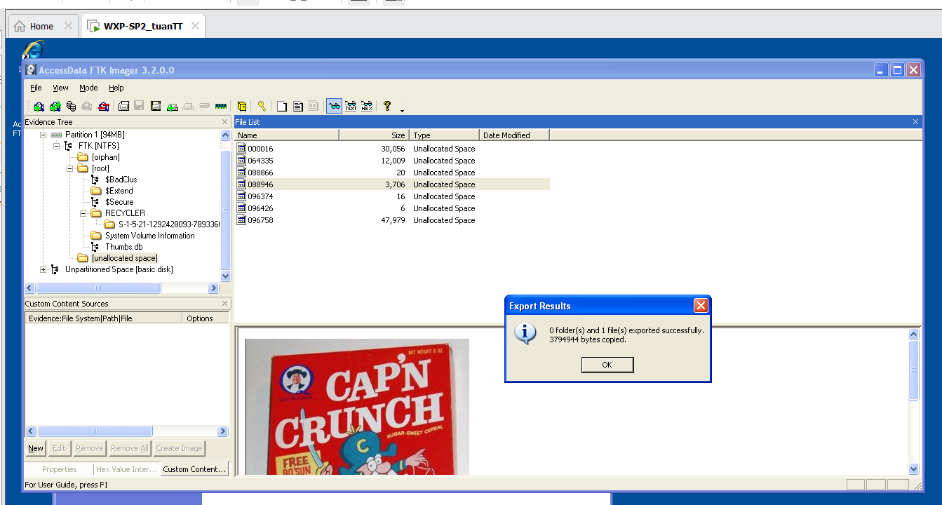

***View Recoverd Picture***

1. **Open My Computer**

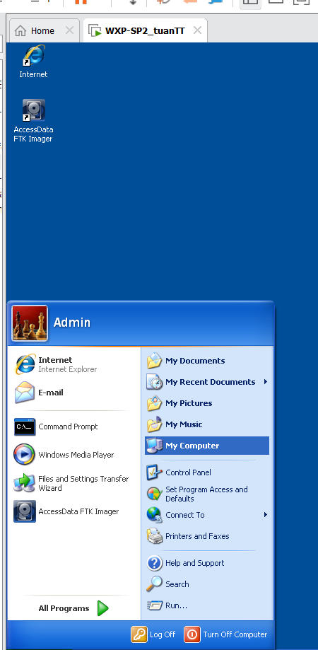

1. **Rename File**

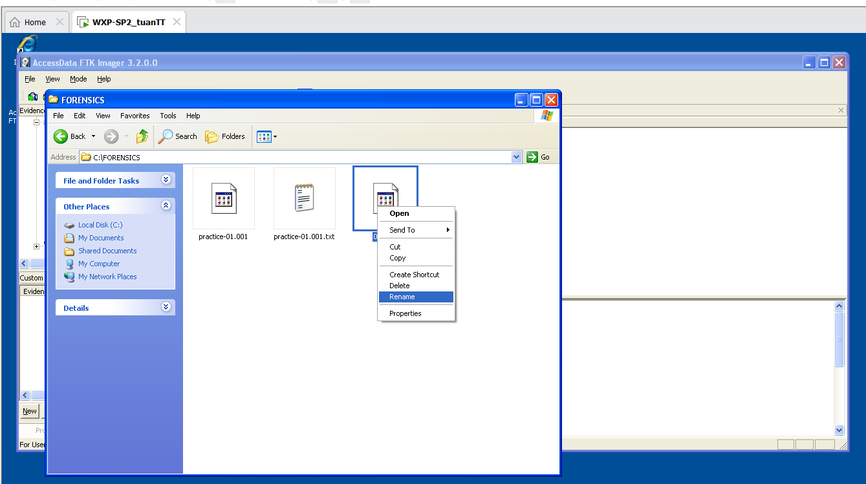

1. **Name File**

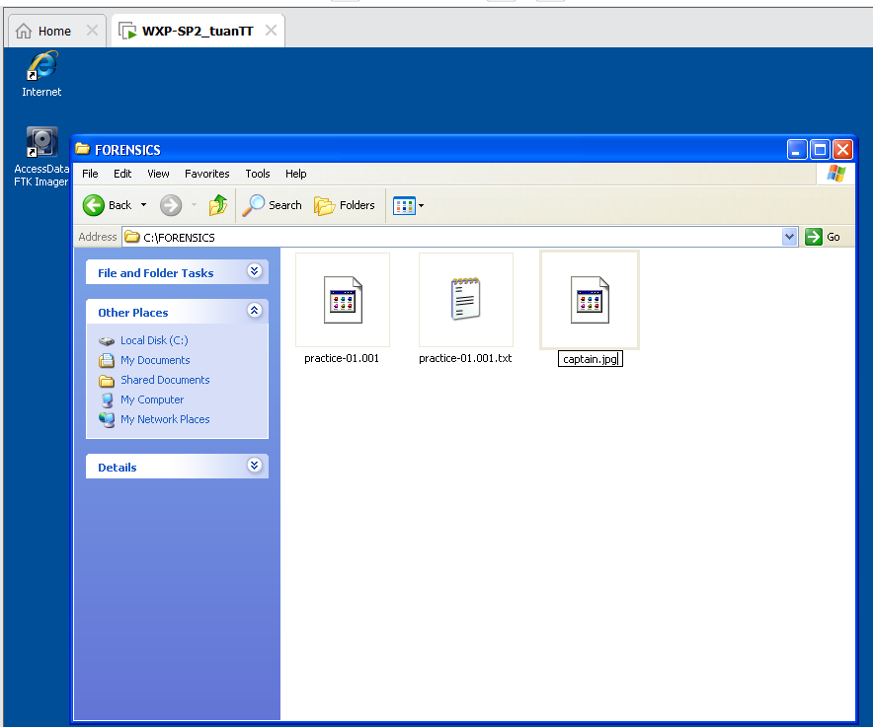

1. **Open File**

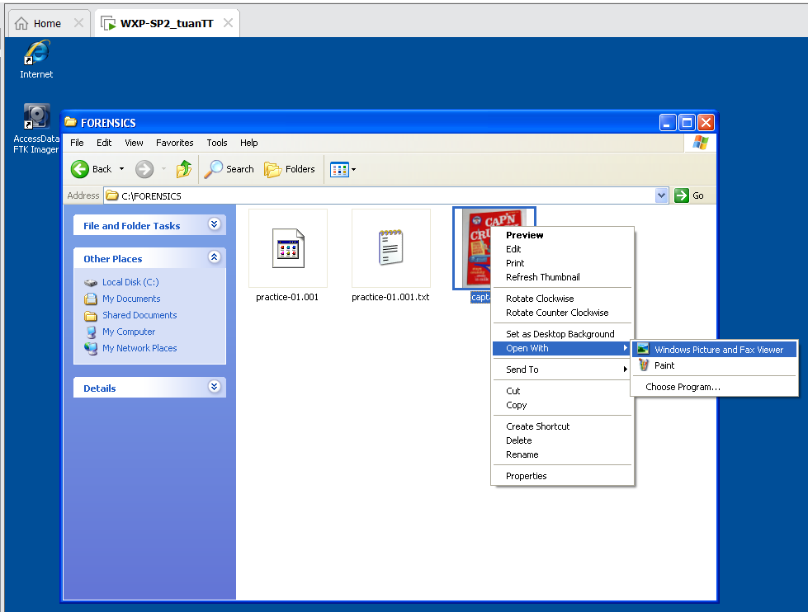

1. **View File**

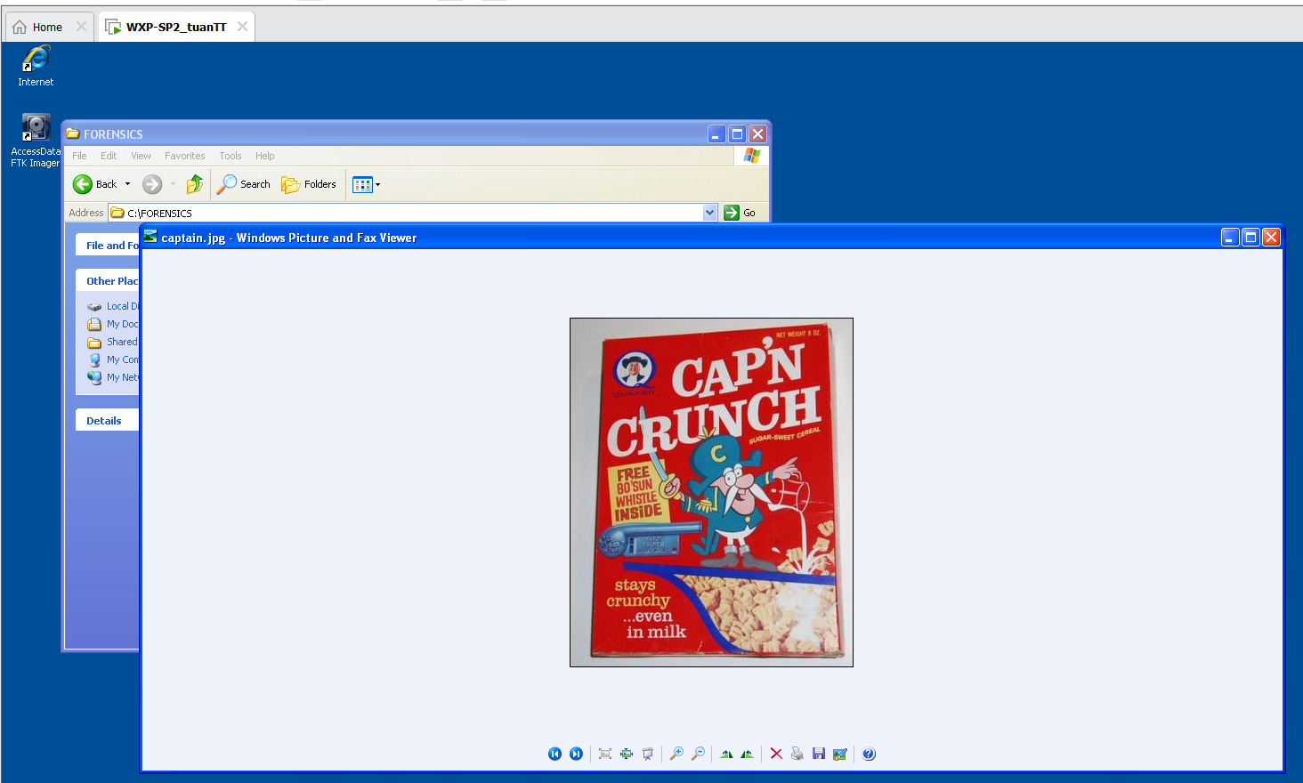

***Calculate Post MD5 Hash***

1. **Verify Image**

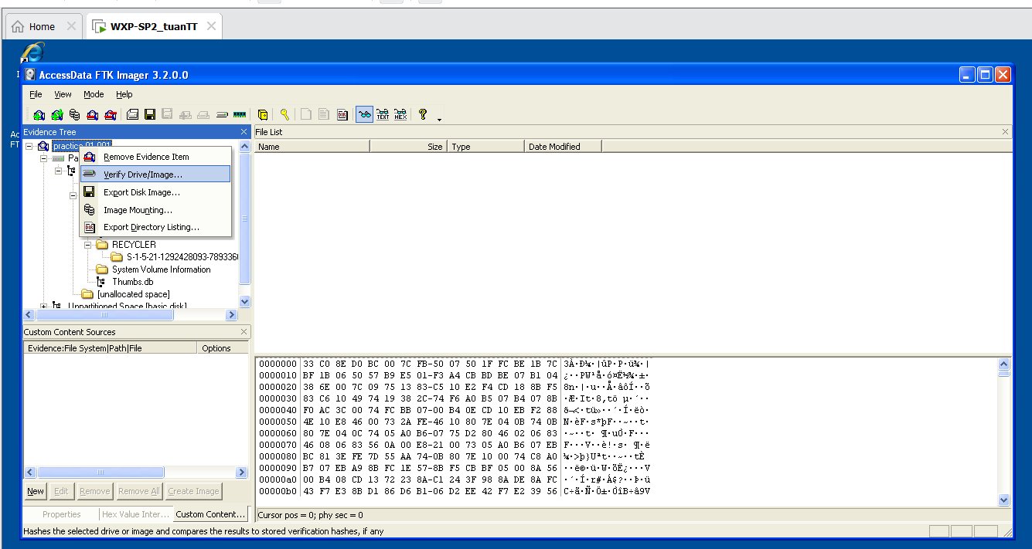

1. **Drive/Image Verify Results**

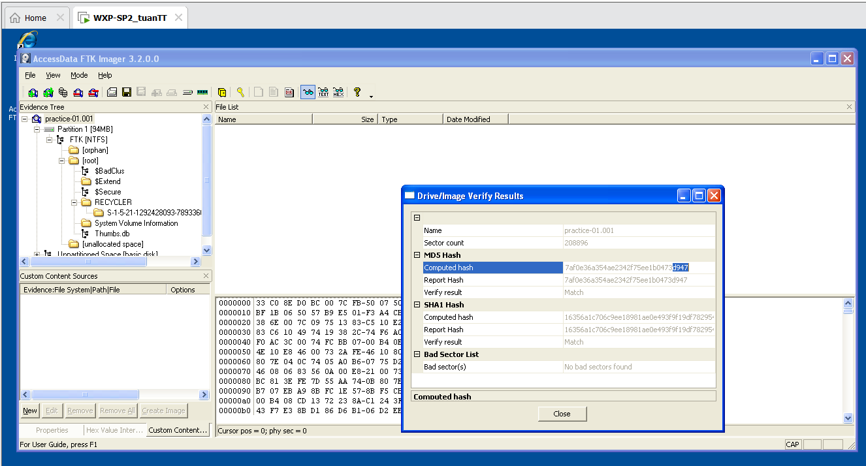

***Proof of Lab***

1. **Open a Command Prompt**

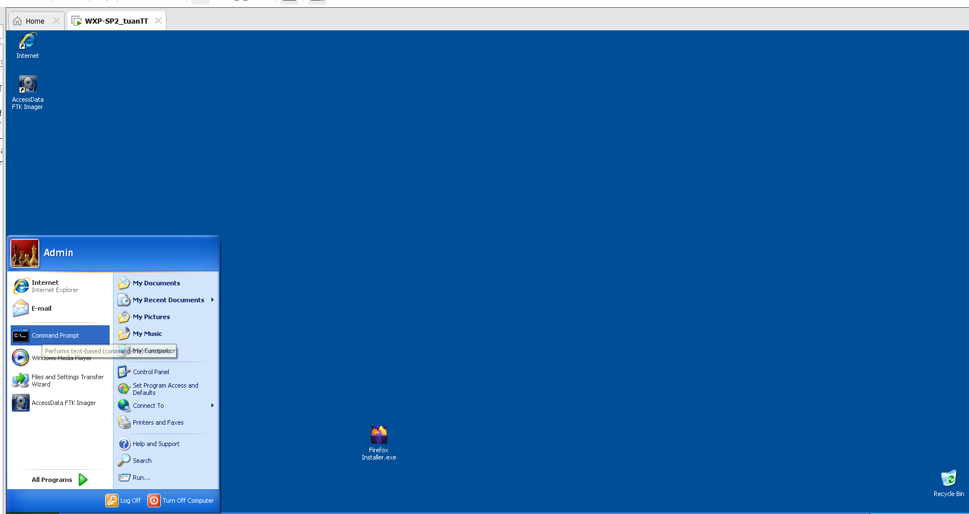

1. **Proof of Lab**

